**PEDESTAL DELUXE AC/DC FANS:**

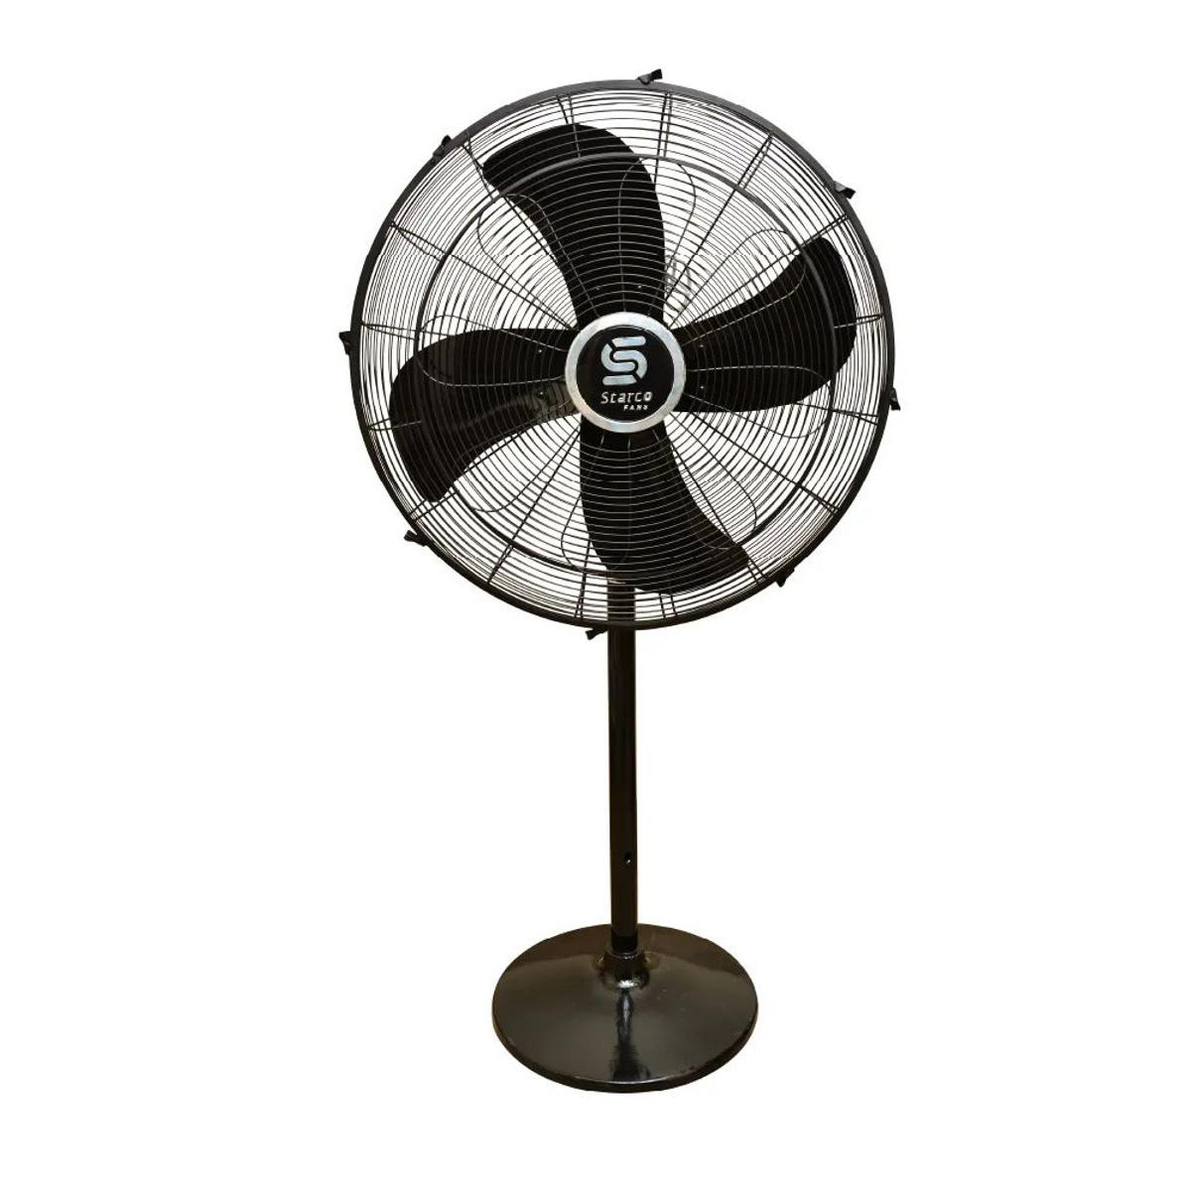

**Price: 14,895.00**

The Pedestal Deluxe AC/DC Fan is a versatile and reliable cooling solution, designed to provide powerful airflow in various settings. This fan features a sturdy and adjustable pedestal design, allowing for customizable height and direction. With its advanced AC/DC motor, the Pedestal Deluxe AC/DC Fan ensures efficient energy use and consistent performance. Its sleek and modern design makes it perfect for homes, offices, and commercial spaces, while its dual-power capability allows for seamless transition between AC and DC power sources, ideal for areas with frequent power outages.

**Key features of deluxe pedestal ac/dc fans include:**

* **Adjustable Height:** Customizable height for optimal air distribution.
* **Oscillation:** Provides widespread cooling by rotating from side to side.
* **Multiple Speed Settings:** Offers low, medium, and high speeds for flexible airflow control.
* **Quiet Operation:** Engineered for minimal noise during operation.
* **Sturdy Build:** Durable construction for long-lasting use.
* **Tilt Adjustment:** Allows airflow to be directed up or down for better coverage.